Settlement Summary

Path : Reports >> Settlement Summary.

Steps to reach Settlement Summary:
Step 1 : Reports in Steps to reach Settlement Summary : Open the Reports module from the Billing Application(POS).
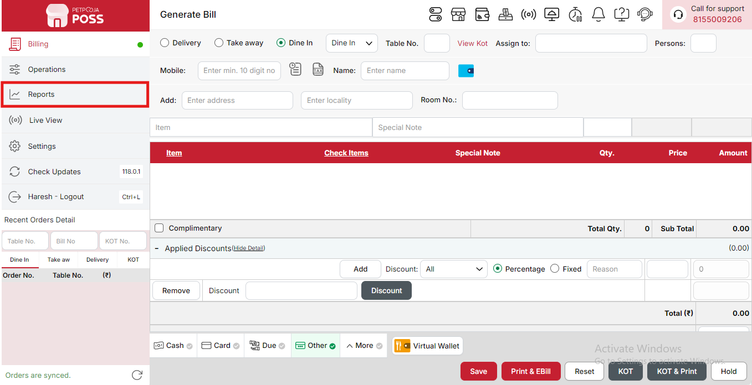
{Image Name: Reports Option,
Description: The red box highlights the “Reports” option in the sidebar menu. This section allows users to view and analyze various business reports, such as sales, billing, and order summaries, helping in effective tracking and decision-making.Here is an image of Step 1 Report in Steps to Reach Settlement Summary.}
Step 2 : Settlement Summary in Steps to reach Settlement Summary : Select Settlement Summary to view detailed information on payment settlements, including amounts collected through different payment modes like cash, card, and online transactions.
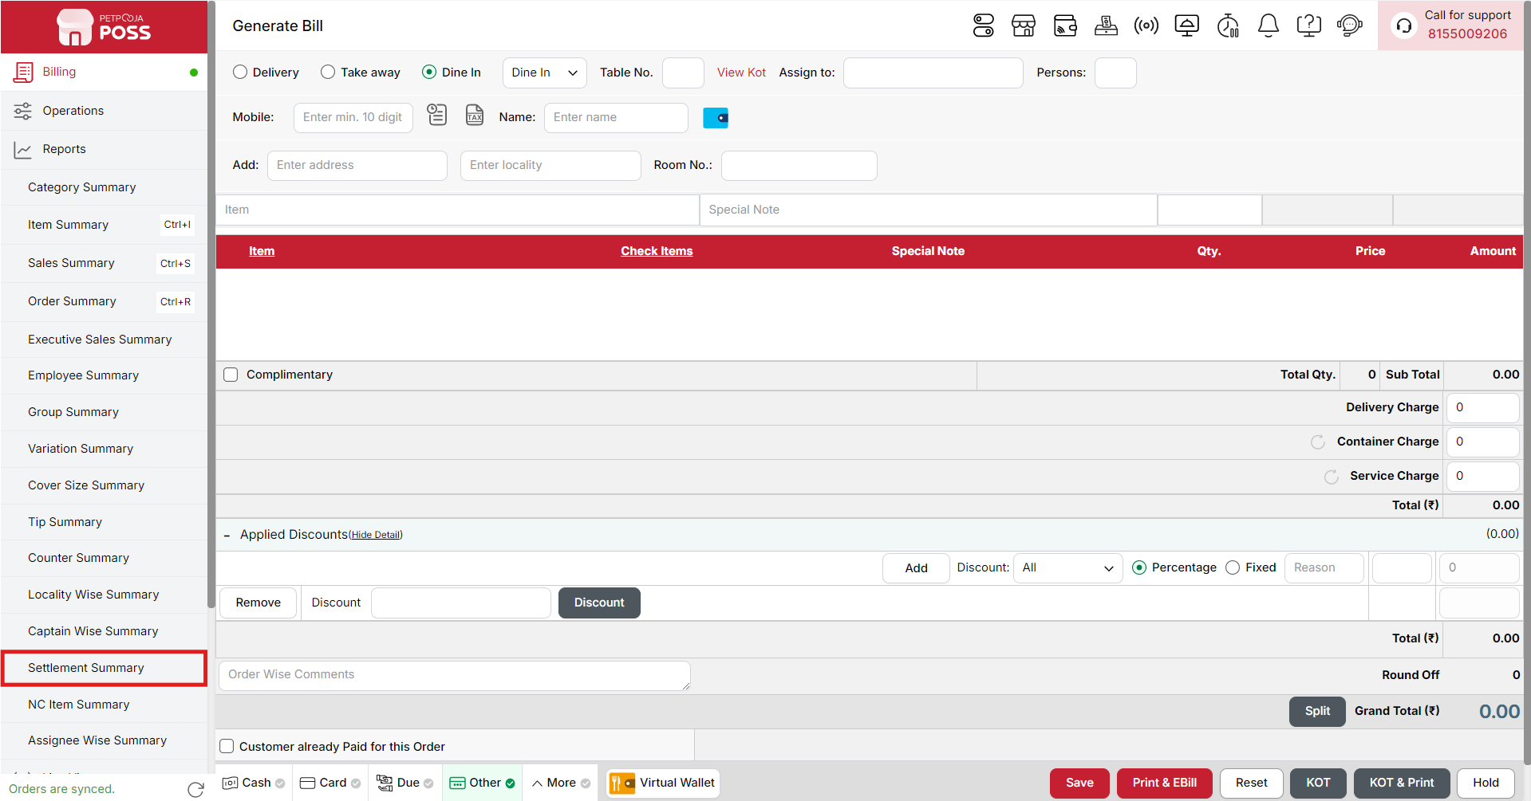
{Image Name: Settlement Summary,
Description: The red box highlights the Settlement Summary option under the Reports section. This report provides a breakdown of payments received through various modes such as cash, card, or online, helping in daily reconciliation and accurate financial tracking.Here is an image of Step 2 Settlement Summary in Steps to Reach Settlement Summary.}

Key features of Settlement Summary :
(Settlement Summary) Note: If you are not able to see or use the Settlement Summary option in your billing application, it means that you do not have the required permission. To enable this, you need to go to the Owner Dashboard and open the User Management section. Inside User Management, you will find a permission called Settlement Summary Show Button — you must checkmark this option to give access.If you are not able to view old day reports, then you also need to enable the Days Restriction permission. Inside the same User Management section, select No Restriction so that you can view reports for any date.After allowing these permissions, perform a manual sync so the system updates the rights properly. Once the sync is done, log out from the billing application and then log in again. After this process, the Settlement Summary option will become visible, and you will be able to view all reports without any problem.

- (Settlement Summary) Settlement Summary: Displays a detailed summary of all transactions handled at each billing counter and by each user. It combines sales, payments, and dues to give a clear financial picture.
- (Settlement Summary) Counter Name: Represents the billing counter or point-of-sale terminal where the transactions were processed. This helps identify which counters generated the most sales.
- (Settlement Summary) Billing User: Indicates the name of the staff member or user responsible for billing at that counter. It helps track individual performance and accountability.
- (Settlement Summary) No of Orders: Shows the total number of orders processed by the billing user at that counter, reflecting their workload and efficiency.
- (Settlement Summary) Net Sales (₹): Displays the total sales amount before adding taxes or applying discounts, representing the gross revenue from each user.
- (Settlement Summary) Total Sales (₹): Represents the overall sales amount after including taxes and applying discounts or adjustments. This shows the actual revenue collected.
- (Settlement Summary) Waived off (₹): Shows the total value of bills or amounts waived off by management, including write-offs or manual adjustments.
- (Settlement Summary) Cash (₹): Displays the total payments received in cash by the billing user.
- (Settlement Summary) Card (₹): Shows the total payments collected through card transactions processed by the user.
- (Settlement Summary) Due Payment (₹): Represents the pending or unpaid amounts from customers, helping track amounts yet to be collected.
- (Settlement Summary) Other (₹): Includes payments received through miscellaneous modes such as coupons, credits, or vouchers not categorized under cash or card.
- (Settlement Summary) Wallet (₹): Displays payments made through digital wallet platforms like Paytm or PhonePe.
- (Settlement Summary) Online Cash (₹): Represents payments made digitally but treated as cash equivalents, such as UPI payments categorized as cash.
- (Settlement Summary) Online Paid (₹): Shows payments fully received online, such as prepaid app transactions.
- (Settlement Summary) Sub Total: Displays the combined subtotal for each counter, summing up all users under that counter.
- (Settlement Summary) Total: Represents the overall financial summary across all counters and users, providing a complete picture of sales, payments, and dues for the day.

Search Button (Settlement Summary) : The Search button is used to find the report for a specific date or time. It helps you quickly see sales details for the selected period. After choosing the date or time, you can click on Search to view the report.

- From (Settlement Summary) : The From option is used to select the starting date for the settlement report. It means the report will begin from this date.
- To (Settlement Summary) : The To option is used to select the ending date for the settlement report. It means the report will show data up to this date.
- Time Wise Option (Settlement Summary) : The Time Wise Option is used when you want to see the report for a specific time period within a day. After turning it ON, you can choose both date and time — for example, from 10:00 AM to 5:00 PM — to see sales during that time. If you keep this option OFF (Without Time Wise Option), then the report will show the whole day’s data for the selected date range without filtering by time.
Configure Column (Settlement Summary): Used to show or hide different columns in the report by checking or unchecking the boxes. If you want to see that option in the report, you have to check it, and if you want to hide it, you have to uncheck it.
- (Configure Column) Billing User: Shows the name of the billing user who handled the transactions. You can check this to display it in the report or uncheck it to hide it.
- (Configure Column) No of Orders: Shows the total number of orders processed by the billing user. You can check this to view it in the report or uncheck it to hide it.
- (Configure Column) Net Sales (₹): Shows the total sales amount before adding taxes and after applying discounts. You can check this to view it in the report or uncheck it to hide it.
- (Configure Column) Total Sales (₹): Shows the final sales amount including taxes and after discounts. You can check this to display it in the report or uncheck it to hide it.
- (Configure Column) Waived off (₹): Shows the total amount that was waived off from the bill. You can check this to see waived-off details or uncheck it to hide them.
- (Configure Column) Cash (₹): Shows the total amount received through cash payments. You can check this to display cash transactions in the report or uncheck it to hide them.
- (Configure Column) Card (₹): Shows the total amount received through card payments. You can check this to view card payment details or uncheck it to hide them.
- (Configure Column) Due Payment (₹): Shows the total amount that is still due or pending for payment. You can check this to see pending payment details or uncheck it to hide them.
- (Configure Column) Other (₹): Shows the total amount received through other payment modes (if any). You can check this to display it in the report or uncheck it to hide it.
- (Configure Column) Wallet (₹): Shows the total amount received through wallet payments. You can check this to include wallet transactions in the report or uncheck it to hide them.
- (Configure Column) Online Cash (₹): Shows the total amount received through online cash payment methods. You can check this to display it in the report or uncheck it to hide it.
- (Configure Column) Online Paid (₹): Shows the total amount successfully paid online by customers. You can check this to view online payment details or uncheck it to hide them.
(Settlement Summary) Print Button: The Print Button is used to print the report. If you want to take a printout of the report, you just need to click on the Print button.
If you get an error saying “Please assign one printer for report print”, then follow these steps:
- Go to Operation → Bill/KOT Print → Multiple Printer Settings.
- Select and edit one printer that you want to use for printing the report.
- In that printer setting, there is an option called “Use this printer for report print”.
- Check this box and save the setting.
After doing this, you will be able to print the report successfully using the selected printer.
(Settlement Summary) Print Configuration: This section is used to set how your report will look when you print it. You can change the format, size, and what details to show on the printed page.
- (Print Configuration) Show Bill Header: If you check this option, the header (top part with company or shop name) will appear on the print.
- (Print Configuration) Show Bill Footer: If you check this option, the footer (bottom part with notes or messages) will appear on the printed report.
- (Print Configuration) NONE: Select this option if you don’t want to apply any specific print format or layout. The report will print in the default basic format without additional formatting or sections.
- (Print Configuration) Display To Date on Print: If you check this option, the “To Date” of the report will be shown on the printed page.
- (Print Configuration) Display Time on Print: If you check this option, the time will be displayed on the print along with the date.
- (Print Configuration) Display Summary Box on Print: If you check this option, a summary box will appear at the end of the report showing total amounts and other summary details.
- (Print Configuration) Display Print Date & Time on Print: If you check this option, the date and time when the report was printed will appear on the print.
- (Print Configuration) Main Width: Used to set the width of the report on the printed page. For example, 500 means the report will be printed with that width size.
- (Print Configuration) Font Size: Used to set the text size of the printed report. You can increase or decrease it as needed.
- (Print Configuration) Cancel: Click this button to close the print configuration window without saving any changes.
- (Print Configuration) Save:Click this button to save all the changes you made in the print configuration settings.
(Settlement Summary) Export Excel: If you want to download or save the report in Excel format, you have to click on the Export Excel button. This will create an Excel file of the report that you can open and use in Microsoft Excel.

